＊停修完成確認 Confirmation of course Withdrawal
(請務必留存及保留系統發出的信件，若有問題請提出此證明向課務組反應，謝謝！)
(Please save and keep the e-mail from the automatic system, you can then show it to the Curriculum Section if there are any problems.)

- 如何申請停修？(圖解流程)
How to apply for a course Withdrawal? (See the illustration below.)
步驟一：登入個人portal / 學習檔案 /停修，詳閱說明後按下「開始申請（APPLY）」。
Step 1: Portal/ Student File/ Course Withdrawal. Click the “APPLY” button below.

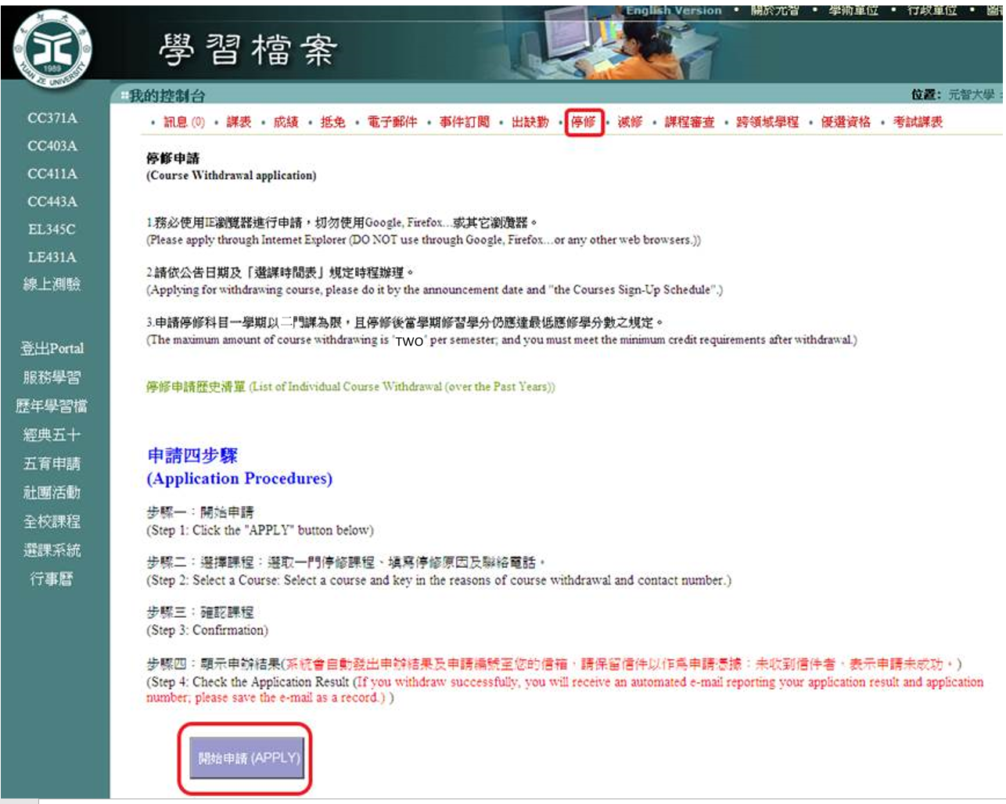

步驟二：選取一門停修課程 → 填寫行動電話及停修理由(務必要填，否則系統不會送出！) →填寫完成，按下「下一步（NEXT）」。
Step 2: Select the course you wish to withdrawal from →Must enter your contact number and the reasons for withdrawing → Press “Next”
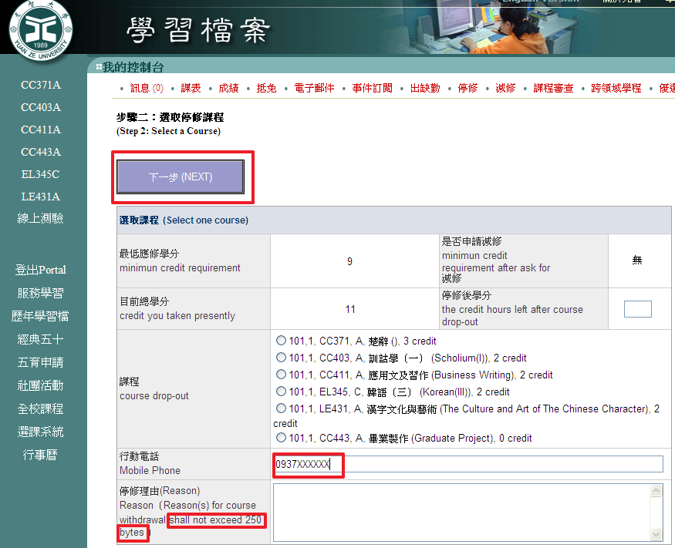
步驟三：課程確認，按下「Yes」鍵，系統會自動發信至老師及學生信箱。
Step 3: Confirmation. Press“Yes”, You will receive an automated e-mail.
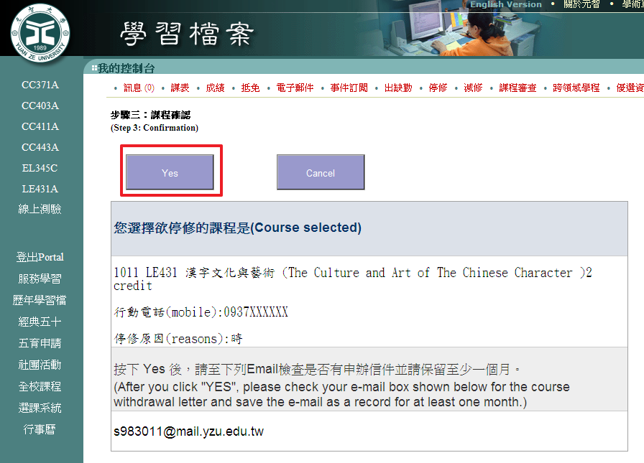
步驟四：顯示申請結果
Step 4: Check the Application Result.
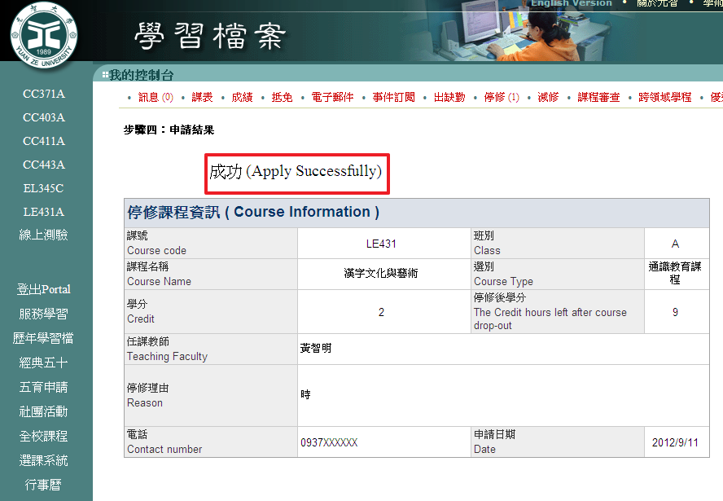

請確認審核結果出現「待審中」，才完成停修申請，並至信箱確認是否收到系統發出信件。(建議您可以自行留存及保留系統發送信件以作為申請憑據，若有問題可提出此證明向課務組反應，謝謝！)
Please make sure you can see “Under Review” in the Review and Comments column, which means you are in the application process, and make sure you have received an email from the automatic system. (It is recommended that to save and keep the email received, you can then show it to the Curriculum Section if there are any problems.)

