**想了解學程訊息，要去那裡得知學程訊息呢？**

where can you go to obtain program details If you want to find information about a program.

①教務處網頁有全校跨領域學程介紹連結：

The Office of Academic Affairs website has a link to the introduction of school-wide interdisciplinary programs：

(位置：首頁→教務處→學生專區→學程申請→跨領域學程一覽表)

( location: Homepage→ office of academic affairs→ Students’ Resource→Application Program→ The List of Interdisciplinary Course Program)

<https://www.yzu.edu.tw/admin/aa/index.php/tw/2016-01-14-06-58-46/2016-03-13-13-02-53/interdisciplinary-course-program>

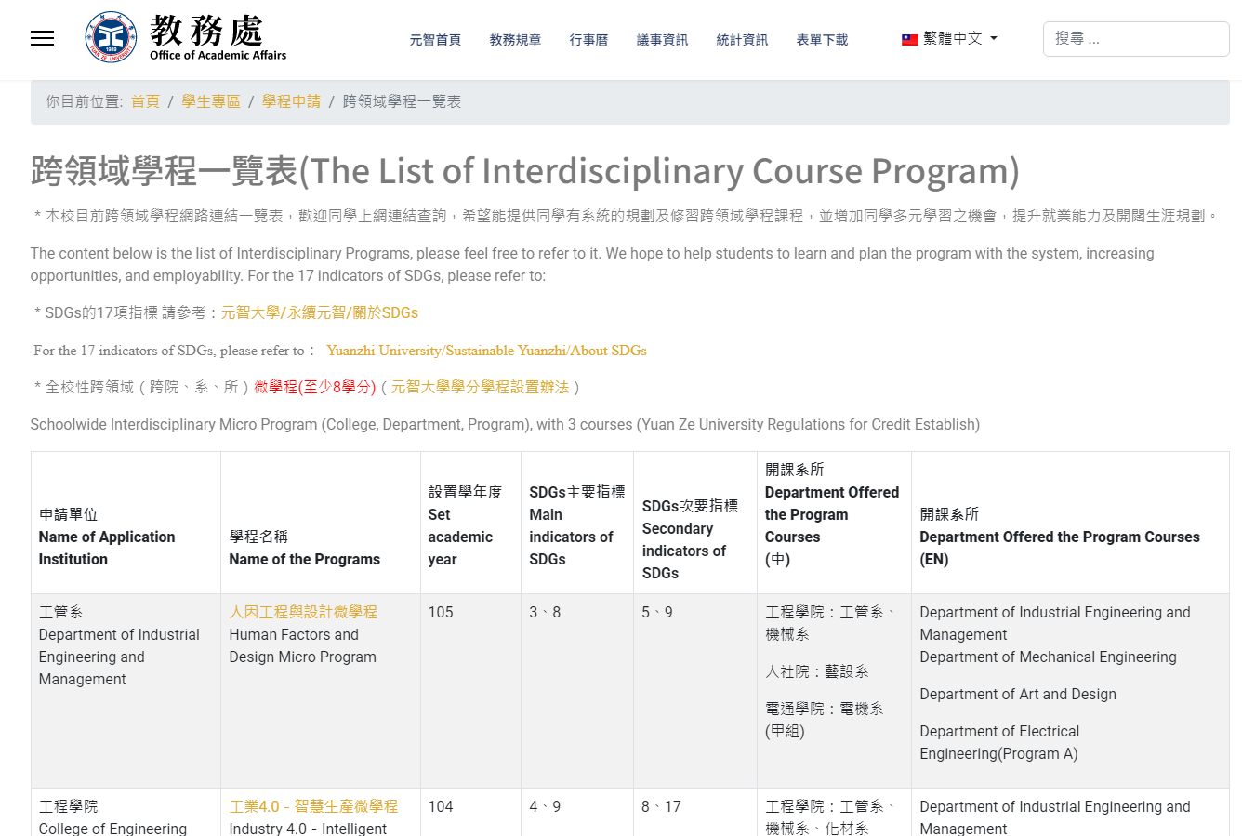

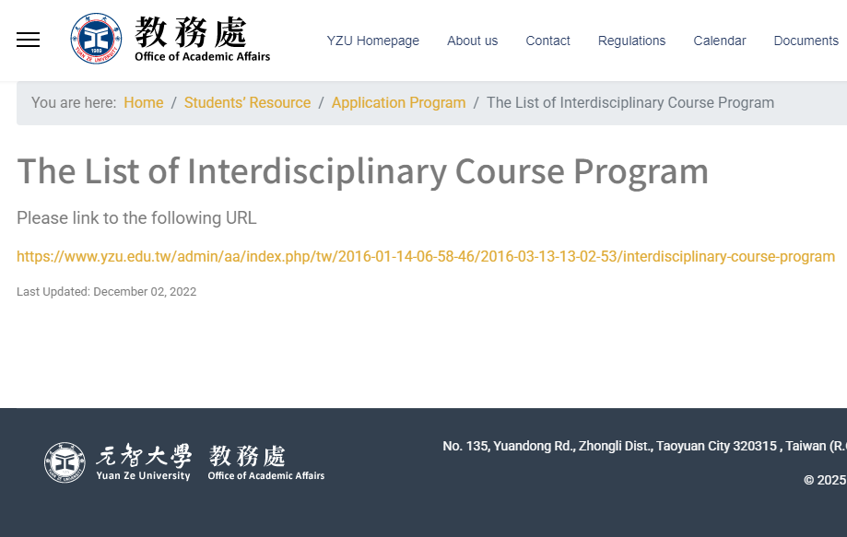

②於「課程資訊」中查詢各學程課程訊息：

You can find information about various program courses under "Course Information."：

(首頁→選課系統→元智大學課程查詢系統)

(Homepage→ Portal→ Course Selection→ Course Selection System→ Yuan Ze University - University Curriculum)

<https://portalfun.yzu.edu.tw/cosSelect/Index.aspx>

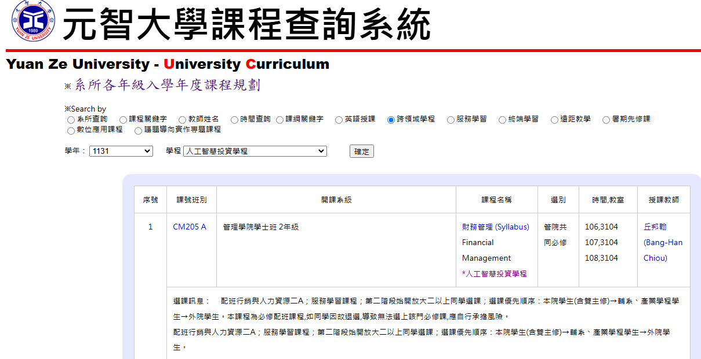

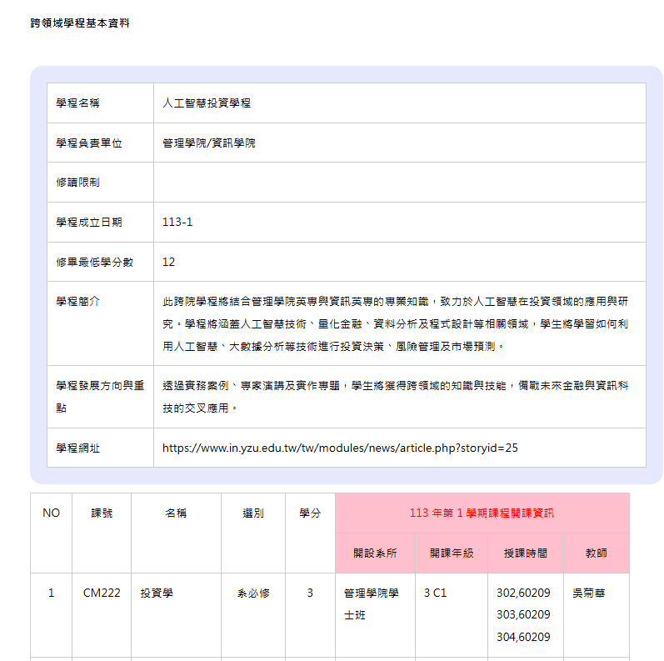

③如何線上申請學程？

How to apply for a program online?

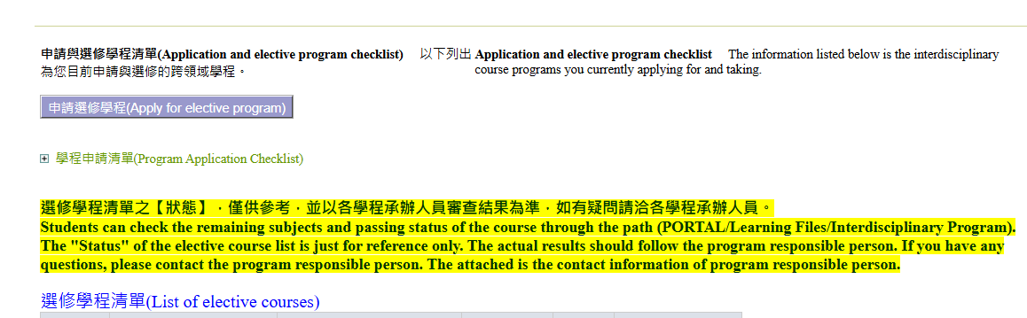

1. **學生點選申請**

**選修學程**

**(個人portal  學習檔案 跨領域學程)**

1. **Click** **Apply for elective Program**

**(Portal  learning profile Interdisciplinary program)**

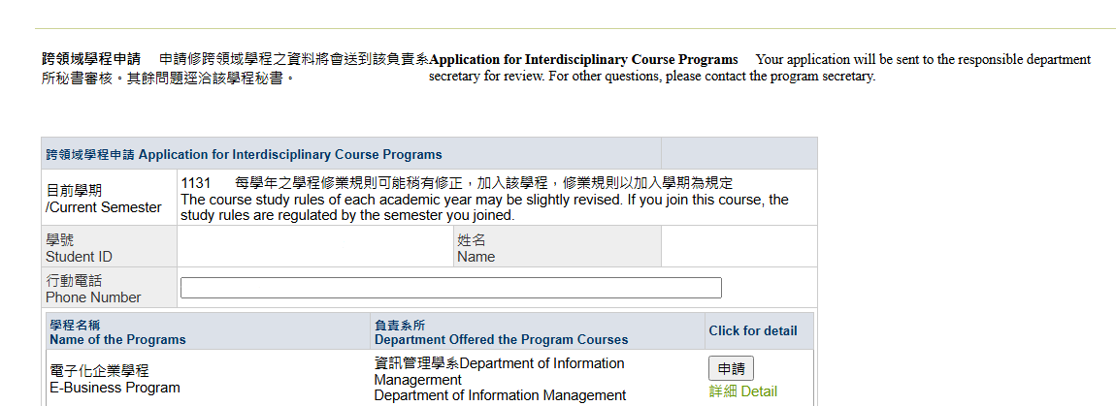

**2.1學生針對將要修讀的學程，點選申請。**

**Students can click 'Apply' for the program they intend to enroll in.**

**2.2秘書請於秘書代工中點選同意或不同意。**

**The secretary, please select 'Agree' or 'Disagree' under the secretary's approval.**

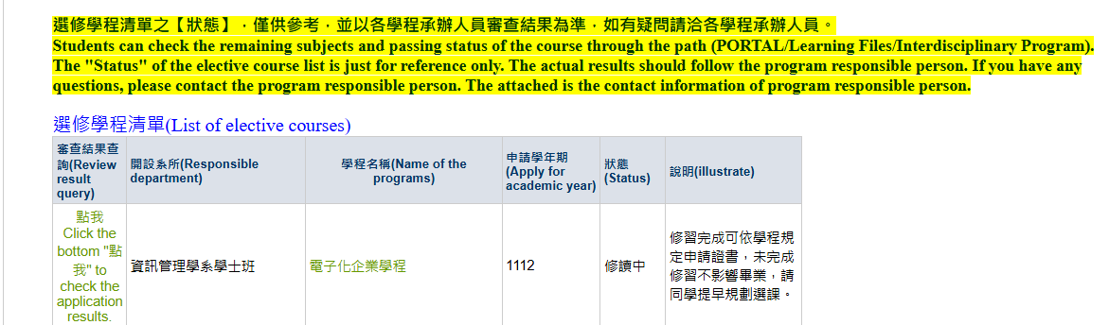

**3.學程秘書同意該生修讀該學程後，即會出現在選修學程修單。於審查結果查詢點選”點我”，即會帶出該生已修過之課程年度及成績。**

**3.** **Once the program secretary agrees that the student should take the program, it will appear on the elective program list. Click "Click Here" in the review results query, which will bring up the course years and grades the student has taken.the student has already completed.**

